NOTE: Run these lines first
If you run into technical issues ask Shaik Mohammed Ali
USE AusRetail_Demo;
GO
MODULE 1
SECTION 1: DQL EXERCISES (Data Query Language)
-- Exercise 1.1: Basic SELECT with WHERE
PRINT '--- Exercise 1.1: Basic SELECT with WHERE ---';
PRINT 'Task: Find all stores in New South Wales (NSW)';
PRINT 'Expected columns: StoreName, City, Manager';
PRINT '';
PRINT '-- YOUR SQL HERE:';
SELECT StoreName,City,Manager
FROM Stores
WHERE State = 'NSW';
GO
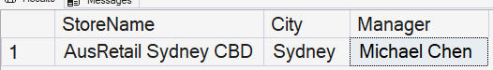

-- Exercise 1.2: SELECT with Aggregation
PRINT '--- Exercise 1.2: SELECT with Aggregation ---';
PRINT 'Task: Calculate the average salary by department';
PRINT 'Expected columns: Department, AverageSalary, NumberOfEmployees';
PRINT 'Hint: Use AVG(), COUNT(), and GROUP BY';
PRINT '';
PRINT '-- YOUR SQL HERE:';
SELECT Department, AVG(Salary) as AverageSalary, COUNT(EmployeeID) as NumberOfEmployees
FROM Employees
GROUP BY Department
ORDER BY AverageSalary DESC;
PRINT '';
PRINT '';
GO
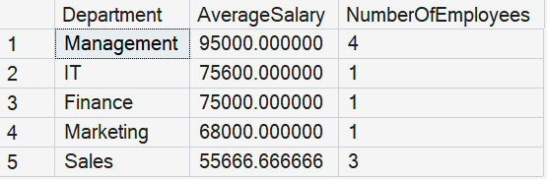

-- Exercise 1.3: SELECT with JOIN
PRINT '--- Exercise 1.3: SELECT with JOIN ---';
PRINT 'Task: Show all sales with store name, product name, and employee name';
PRINT 'Expected columns: SaleDate, StoreName, ProductName, EmployeeName, TotalAmount';
PRINT 'Hint: You need to JOIN 4 tables (Sales, Stores, Products, Employees)';
PRINT '';
PRINT '-- YOUR SQL HERE:';
SELECT
sa.SaleDate,
st.StoreName,
p.ProductName,
e.FirstName + ' ' + e.LastName AS EmployeeName,
sa.TotalAmount
FROM Sales sa
INNER JOIN Stores st ON sa.StoreID = st.StoreID
INNER JOIN Products p ON sa.ProductID = p.ProductID
INNER JOIN Employees e ON sa.EmployeeID = e.EmployeeID
ORDER BY sa.SaleDate DESC;
PRINT '';
PRINT '';

GO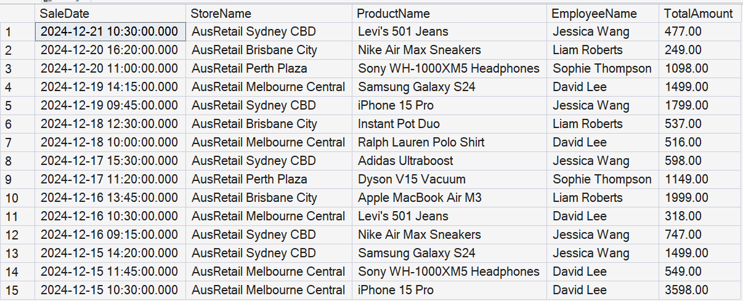

-- Exercise 1.4: Business Analysis Query
PRINT '--- Exercise 1.4: Business Analysis Query ---';
PRINT 'Task: Find which store has generated the most revenue';
PRINT 'Expected columns: StoreName, State, TotalRevenue, NumberOfSales';
PRINT 'Hint: Use SUM(), COUNT(), GROUP BY, and ORDER BY';
PRINT '';
PRINT '-- YOUR SQL HERE:';
SELECT
TOP (1) st.StoreName,
st.[State],
SUM(sa.TotalAmount) as TotalRevenue,
COUNT(sa.SaleID) as NumberOfSales
FROM Sales sa
INNER JOIN Stores st ON sa.StoreID = st.StoreID
GROUP BY st.StoreName,st.[State]
ORDER BY TotalRevenue DESC;
PRINT '';
PRINT '';
GO

-- Exercise 1.5: Advanced Query
PRINT '--- Exercise 1.5: Advanced Query ---';
PRINT 'Task: Find products that have sold more than 3 units total';
PRINT 'Expected columns: ProductName, Category, TotalUnitsSold, TotalRevenue';
PRINT 'Hint: Use JOIN, SUM(), GROUP BY, and HAVING';
PRINT '';
PRINT '-- YOUR SQL HERE:';
SELECT
p.ProductName,
p.Category,
SUM(sa.Quantity) AS TotalUnitsSold,
SUM(sa.TotalAmount) AS TotalRevenue
FROM Sales sa
INNER JOIN Products p ON p.ProductID = sa.ProductID
GROUP BY p.ProductName, p.Category
HAVING SUM(sa.Quantity) > 3; -- MUST BE MENTIONED DURING THE SELECT CLAUSE
PRINT '';
PRINT '';
GO

SECTION 2: DML EXERCISES (Data Manipulation Language)
-- Exercise 2.1: INSERT new data
PRINT '--- Exercise 2.1: INSERT new data ---';
PRINT 'Task: Add a new product to the Products table';
PRINT 'Product Details:';
PRINT ' - ProductName: "Apple AirPods Pro"';
PRINT ' - Category: "Electronics"';
PRINT ' - UnitPrice: 399.00';
PRINT ' - CostPrice: 280.00';
PRINT ' - StockQuantity: 50';
PRINT ' - IsActive: 1';
PRINT '';
PRINT '-- YOUR SQL HERE:';
PRINT '';
PRINT '';
GO
INSERT INTO Products (ProductName, Category, UnitPrice, CostPrice, StockQuantity, IsActive)
VALUES
('Apple AirPods Pro', 'Electronics', 399.00, 280.00, 50,1);
GO
PRINT '✓ Inserted new product into Products!';
PRINT '';
GO

-- Exercise 2.2: UPDATE with WHERE
PRINT '--- Exercise 2.2: UPDATE with WHERE ---';
PRINT 'Task: Increase the stock quantity of all Footwear products by 10';
PRINT 'Steps:';
PRINT ' 1. BEGIN TRANSACTION';
PRINT ' 2. SELECT to preview (WHERE Category = ''Footwear'')';
PRINT ' 3. UPDATE StockQuantity = StockQuantity + 10';
PRINT ' 4. SELECT again to verify';
PRINT ' 5. COMMIT or ROLLBACK';
PRINT '';
PRINT '-- YOUR SQL HERE:';
PRINT '';
PRINT '';
GO

PRINT '✓ SAFE UPDATE - Step 1: Preview with SELECT';
SELECT * -- For my learning
FROM Products
WHERE Category = 'Footwear';
GO
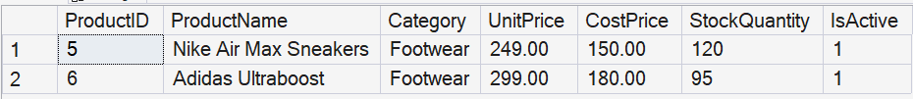
PRINT '';
PRINT '✓ SAFE UPDATE - Step 2: UPDATE with WHERE clause';
UPDATE Products
SET StockQuantity = StockQuantity + 10
WHERE Category = 'Footwear';
GO

PRINT '';
PRINT '✓ SAFE UPDATE - Step 3: Verify the change';
SELECT * -- For my learning
FROM Products
WHERE Category = 'Footwear';
GO
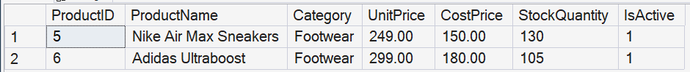
StockQuantity has increased up to 10.
-- Exercise 2.3: DELETE with WHERE
PRINT '--- Exercise 2.3: DELETE with WHERE ---';
PRINT 'Task: First INSERT a test employee, then DELETE them';
PRINT 'Test Employee Details:';
PRINT ' - FirstName: "Practice"';
PRINT ' - LastName: "Student"';
PRINT ' - Email: "practice.student@ausretail.com.au"';
PRINT ' - Department: "Training"';
PRINT ' - Position: "Intern"';
PRINT ' - Salary: 45000.00';
PRINT ' - HireDate: Today''s date';
PRINT ' - StoreID: 1';
PRINT '';
PRINT 'Steps:';
PRINT ' 1. INSERT the test employee';
PRINT ' 2. SELECT to confirm insertion';
PRINT ' 3. BEGIN TRANSACTION';
PRINT ' 4. DELETE the test employee';
PRINT ' 5. SELECT to verify deletion';
PRINT ' 6. COMMIT';
PRINT '';
PRINT '-- YOUR SQL HERE:';

PRINT '✓ UPDATE - Step 1: Insert a new employee';
INSERT INTO Employees (FirstName, LastName, Email, Department, Position, Salary,HireDate,StoreID)
VALUES
('Practice','Student','practice.student@ausretail.com.au','Training','Intern',45000.00,GETDATE(),1);
GO

PRINT '✓ Inserted new Employee into Employees!';
PRINT '';
GO

PRINT '✓ UPDATE - Step 2: SELECT to confirm insertion';
SELECT EmployeeID, FirstName, LastName, Salary
FROM Employees
WHERE EmployeeID = 12;
GO

PRINT '✓ UPDATE - Step 3: BEGIN TRANSACTION';
UPDATE Employees
SET Salary = 100000.00
WHERE EmployeeID = 12;
GO

PRINT '✓ SEE THE UPDATE';
SELECT EmployeeID, FirstName, LastName, Salary
FROM Employees
WHERE EmployeeID = 12;
GO

PRINT '✓ UPDATE - Step 4: DELETE the test employee';
DELETE FROM Employees
WHERE FirstName = 'Practice' AND LastName = 'Student';
GO

PRINT '';
PRINT '✓ Test employee deleted successfully';
PRINT '';
GO

PRINT '✓ UPDATE - Step 5: SELECT to confirm deletion';
DELETE FROM Employees
SELECT EmployeeID, FirstName, LastName, Salary
FROM Employees
WHERE EmployeeID = 12;
GO

PRINT '';
PRINT '✓ Test employee deleted successfully';
PRINT '';
GO

PRINT '✓ UPDATE - Step 6: COMMIT';
COMMIT;
GO
PRINT '';
GO

SECTION 3: DDL EXERCISES (Data Definition Language)
-- Exercise 3.1: CREATE TABLE
PRINT '--- Exercise 3.1: CREATE TABLE ---';
PRINT 'Task: Create a new table called "Customers"';
PRINT 'Columns:';
PRINT ' - CustomerID (INT, Primary Key, Auto-increment)';
PRINT ' - FirstName (NVARCHAR(50), NOT NULL)';
PRINT ' - LastName (NVARCHAR(50), NOT NULL)';
PRINT ' - Email (NVARCHAR(100))';
PRINT ' - Phone (NVARCHAR(20))';
PRINT ' - City (NVARCHAR(50))';
PRINT ' - State (NVARCHAR(3))';
PRINT ' - JoinDate (DATE, NOT NULL, DEFAULT today)';
PRINT ' - IsActive (BIT, DEFAULT 1)';
PRINT '';
PRINT '-- YOUR SQL HERE:';
PRINT '';
PRINT '';
GO

CREATE TABLE Customers (
CustomerID INT PRIMARY KEY IDENTITY(1,1),
FirstName NVARCHAR(50) NOT NULL,
LastName NVARCHAR(50) NOT NULL,
Email NVARCHAR(100),
Phone NVARCHAR(20),
City NVARCHAR(50),
State NVARCHAR(3),
JoinDate DATE NOT NULL DEFAULT GETDATE(),
IsActive BIT DEFAULT 1
);
GO

-- Exercise 3.2: ALTER TABLE
PRINT '--- Exercise 3.2: ALTER TABLE ---';
PRINT 'Task: Add a new column to the Employees table';
PRINT 'Column Details:';
PRINT ' - Column Name: EmergencyContact';
PRINT ' - Data Type: NVARCHAR(100)';
PRINT '';
PRINT '-- YOUR SQL HERE:';
PRINT '';
PRINT '';
GO

ALTER TABLE Employees
ADD EmergencyContact NVARCHAR(100);
GO
PRINT '✓ EmergencyContact column added to Employees table!';
PRINT '';
GO

-- Exercise 3.3: CREATE INDEX
PRINT '--- Exercise 3.3: CREATE INDEX ---';
PRINT 'Task: Create an index on the Products table for the Category column';
PRINT 'Index Name: idx_Products_Category';
PRINT 'Hint: This will speed up queries that filter by Category';
PRINT '';
PRINT '-- YOUR SQL HERE:';
PRINT '';
PRINT '';
GO

CREATE INDEX idx_Products_Category
ON Products(Category);
GO
SECTION 4: TCL EXERCISES (Transaction Control Language)
Practice the safety net!
*/

PRINT '================================================================================';
PRINT 'SECTION 4: TCL EXERCISES';
PRINT '================================================================================';
PRINT 'Master the art of safe data manipulation!';
PRINT '';
GO

-- Exercise 4.1: ROLLBACK Practice
PRINT '--- Exercise 4.1: ROLLBACK Practice ---';
PRINT 'Task: Practice using ROLLBACK to undo changes';
PRINT 'Steps:';
PRINT ' 1. BEGIN TRANSACTION';
PRINT ' 2. UPDATE all products to increase UnitPrice by 50%';
PRINT ' 3. SELECT to see the changes';
PRINT ' 4. ROLLBACK to undo (prices too high!)';
PRINT ' 5. SELECT again to verify prices are back to normal';
PRINT '';
PRINT '-- YOUR SQL HERE:';

-- Step 1: Check current salaries
PRINT 'Step 1: Current products before transaction';
SELECT *
FROM Products
WHERE ProductID <= 5
ORDER BY ProductID;
GO

PRINT '';
GO

-- Step 2: Start transaction and update
PRINT 'Step 2: BEGIN TRANSACTION and apply increase UnitPrice by 50%';
BEGIN TRANSACTION;

UPDATE Products
SET UnitPrice = UnitPrice * 1.50;

PRINT '';
GO

-- Step 3: Check what changed
PRINT 'Step 3: Checking salaries after 50% raise';
SELECT *
FROM Products
WHERE ProductID <= 5
ORDER BY ProductID;
GO

--SPECIAL NOTE: STEP 4 ROLLBACK; THIS IS IN CASE YOU MADE A MISTAKE YOU CAN UNDO WHEN RUNNING THE TRANSACTION;

-- Step 5: Check what changed
PRINT 'Step 5: again to verify prices are back to normal';
SELECT *
FROM Products
WHERE ProductID <= 5
ORDER BY ProductID;
GO

MY FINAL TABLE
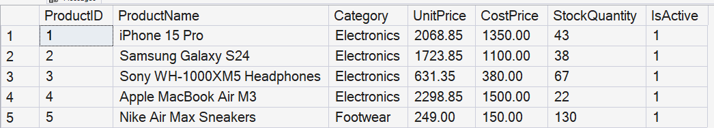

-- Exercise 4.2: COMMIT Practice
PRINT '--- Exercise 4.2: COMMIT Practice ---';
PRINT 'Task: Give all Management employees a 3% raise';
PRINT 'Steps:';
PRINT ' 1. BEGIN TRANSACTION';
PRINT ' 2. SELECT to preview (WHERE Position = ''Store Manager'')';
PRINT ' 3. UPDATE Salary = Salary * 1.03';
PRINT ' 4. SELECT to verify changes';
PRINT ' 5. COMMIT to save permanently';
PRINT '';
PRINT '-- YOUR SQL HERE:';
-- Before Proceeding: Check current salaries
PRINT 'Step 1: Current salaries for manager employees before transaction';
SELECT FirstName,LastName,Position,Salary
FROM Employees
WHERE Position = 'Store Manager'
PRINT '';
GO

-- Steps 1,2 and 3: Start transaction and update Salaries for Store Managers Only
PRINT 'Step 2: UPDATE Salary = Salary * 1.03';
BEGIN TRANSACTION;
UPDATE Employees
SET Salary = Salary * 1.03
WHERE Position = 'Store Manager';

PRINT '';
GO

-- Step 4: Check what changed
PRINT 'Step 3: Checking salaries after 3% raise for store managers';
SELECT FirstName,LastName,Position,Salary
FROM Employees
WHERE Position = 'Store Manager'
PRINT '';
GO

--MAKING SURE, the rest don't get a 3% increase in salary
SELECT FirstName,LastName,Position,Salary
FROM Employees;
PRINT '';
GO

--Step 5 COMMIT
PRINT 'Commit these changes';
COMMIT;
GO

--ROLLBACK; Again in case of mistake

PRINT '';
PRINT '';
GO
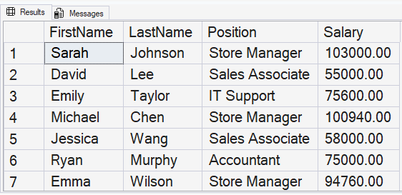

SECTION 5: MIXED CHALLENGE EXERCISES
-- Challenge 1: New Store Setup
PRINT '--- Challenge 1: New Store Setup ---';
PRINT 'Scenario: AusRetail is opening a new store in Gold Coast, Queensland';
PRINT 'Tasks:';
PRINT ' 1. INSERT new store:';
PRINT ' - StoreName: "AusRetail Gold Coast"';
PRINT ' - State: "QLD"';
PRINT ' - City: "Gold Coast"';
PRINT ' - Manager: "Your Name"';
PRINT ' - OpenDate: Today';
PRINT ' - StoreSize: 720';
PRINT ' - IsActive: 1';
PRINT ' 2. INSERT yourself as the new store manager:';
PRINT ' - Use your actual name';
PRINT ' - Department: "Management"';
PRINT ' - Position: "Store Manager"';
PRINT ' - Salary: 88000.00';
PRINT ' - HireDate: Today';
PRINT ' - StoreID: (use the new store you just created)';
PRINT ' 3. SELECT to verify both records were created';
PRINT '';
PRINT '-- YOUR SQL HERE:';

INSERT INTO Stores (StoreName, State, City, Manager, OpenDate, StoreSize,IsActive)
VALUES
-- My New Store
('AusRetail Gold Coast','QLD', 'Gold Coast', 'Michael Le', GETDATE(), 720,1);
GO

PRINT 'Opened my New Store';

INSERT INTO Employees (FirstName, LastName, Department, Position, Salary, HireDate, StoreID)
VALUES
-- New Employee
('Michael','Le','Management','Store Manager',88000.00,GETDATE(),9);
GO
PRINT 'Hired new Manager';

--Check the new enquiries
SELECT * FROM Stores WHERE Manager = 'Michael Le';
SELECT * FROM Employees WHERE FirstName = 'Michael' and LastName = 'Le';
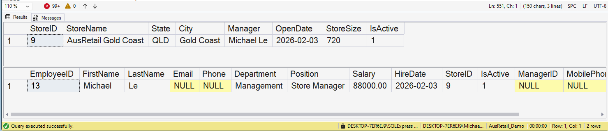

-- Challenge 2: Sales Analysis Report
PRINT '--- Challenge 2: Sales Analysis Report ---';
PRINT 'Scenario: Your manager needs a comprehensive sales report';
PRINT 'Task: Create a query that shows:';
PRINT ' - Each store''s name and state';
PRINT ' - Total revenue';
PRINT ' - Number of transactions';
PRINT ' - Average transaction value';
PRINT ' - Best selling product (product with highest revenue)';
PRINT ' - Sort by total revenue (highest first)';
PRINT 'Hint: This is complex! You may need subqueries or CTEs'; --Unsure google it
PRINT '';
PRINT '-- YOUR SQL HERE:';
SELECT st.StoreName, st.state, SUM(sa.TotalAmount) AS TotalRevenue, COUNT(sa.SaleID) as TotalTransactions,
AVG(sa.TotalAmount) AS AverageTransaction
FROM Stores st
LEFT JOIN Sales sa ON st.StoreID = sa.StoreID
GROUP BY st.StoreName, st.State
ORDER BY TotalRevenue DESC;

PRINT '';
GO

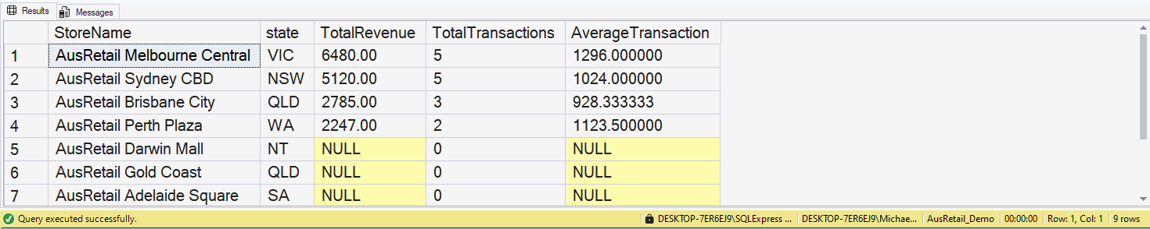

-- Challenge 3: Data Cleanup
PRINT '--- Challenge 3: Data Cleanup ---';
PRINT 'Scenario: Clean up inactive records safely';
PRINT 'Tasks:';
PRINT ' 1. Find all employees marked as inactive (IsActive = 0)';
PRINT ' 2. Using a transaction, DELETE these inactive employees';
PRINT ' 3. Verify the deletion';
PRINT ' 4. Decide whether to COMMIT or ROLLBACK';
PRINT 'Remember: Use the professional workflow!';
PRINT '';
PRINT '-- YOUR SQL HERE:';

-- Since there is no entries of employees that has isActive = 0, otherwise follow the steps, similarly in SECTION 4
SELECT EmployeeID,FirstName,LastName,IsActive
FROM employees WHERE isActive = 0;

PRINT '';
PRINT '';
GO

/*
BONUS CHALLENGE: Build Your Own Analytics
PRINT 'Task: Answer this business question:';
PRINT '"Which employees have generated more than $5,000 in sales,';
PRINT ' and what is their sales performance ranking?"';
PRINT '';
PRINT 'Your query should show:';
PRINT ' - Employee name';
PRINT ' - Store name';
PRINT ' - Total sales revenue';
PRINT ' - Number of sales transactions';
PRINT ' - Performance ranking (1 = best, 2 = second, etc.)';
PRINT 'Hint: Use window functions like ROW_NUMBER() or RANK()'; --Again, when in doubt use Google
PRINT '';
PRINT '-- YOUR SQL HERE:';
--My Attempt
SELECT e.FirstName,
e.LastName,
st.StoreName,
SUM(sa.TotalAmount) AS TotalSalesRevenue,
COUNT(sa.SaleID) AS NumberOfSales,
ROW_NUMBER() OVER (ORDER BY SUM(sa.TotalAmount) DESC) row_number
FROM employees e
INNER JOIN Sales sa ON e.EmployeeID = sa.EmployeeID
INNER JOIN Stores st ON e.StoreID = st.StoreID
GROUP BY e.FirstName,e.LastName,st.StoreName
HAVING SUM(sa.TotalAmount) > 5000;

PRINT '';
PRINT '';
GO
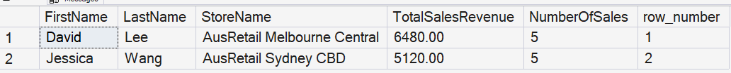

MODULE 2: Validation checks
-- View row counts
PRINT '--- Row counts for each table ---';
SELECT 'Stores' AS TableName, COUNT(*) AS Row_Count FROM Stores
UNION ALL
SELECT 'Products', COUNT(*) FROM Products
UNION ALL
SELECT 'Customers', COUNT(*) FROM customers
UNION ALL
SELECT 'Transactions', COUNT(*) FROM transactions;
GO
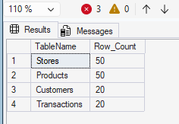

PRINT '--- DataCheck ---';
SELECT TOP 5 * FROM stores ORDER BY store_id;
SELECT TOP 5 * FROM products ORDER BY product_id;
SELECT TOP 5 * FROM transactions ORDER BY transaction_date, transaction_id; 